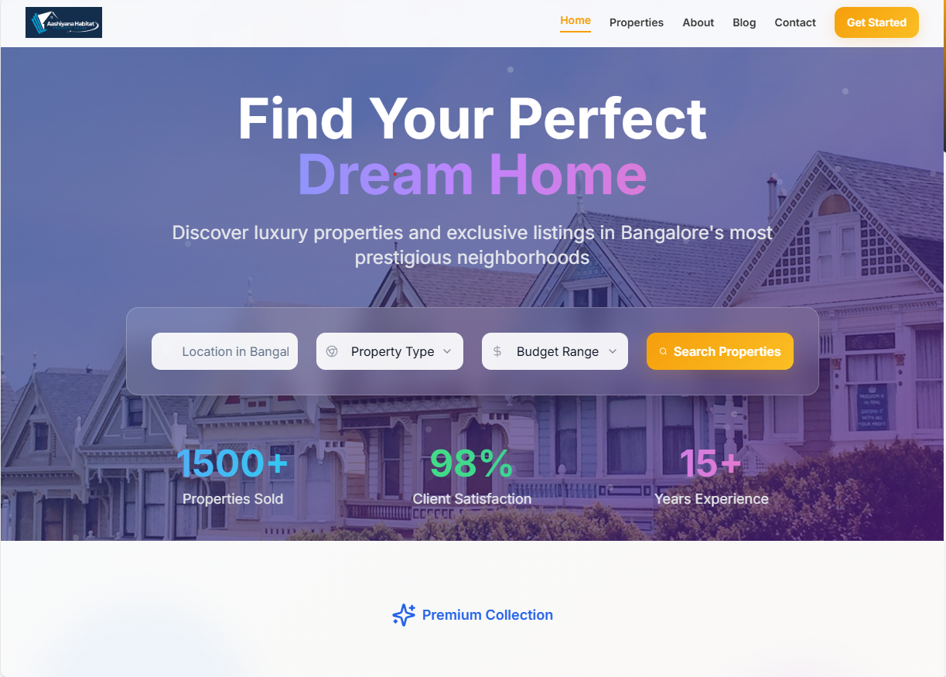

1.CAHNGE THE IMAGE AND COLOURS HERE

ABOUT US PAGE CONTENT

## **About Us**

At Aashiyana Habitat, we believe that real estate is more than just a transaction — it’s a gateway to wealth, lifestyle, and legacy.

Founded with a passion for excellence and a deep understanding of real estate, our firm is dedicated to helping clients build long-term wealth while finding the homes they’ve always envisioned. Whether you’re searching for a refined residence, an investment property, or a statement estate, we specialize in connecting you with properties that align with both your financial goals and personal dreams.

With a client-first approach, we bring together market expertise, strategic insight, and personalized service to create a seamless and rewarding real estate experience. Our team operates with discretion, integrity, and an unwavering commitment to results — ensuring that every client feels understood, valued, and inspired throughout their journey.

At the heart of everything we do is a single, clear purpose:  
**To deliver exceptional value and unlock the full potential of real estate for those who expect nothing less than excellence.**

**Mission Statement**

Our mission is to empower our clients to achieve maximum wealth appreciation through smart, strategic real estate investments, while helping them find not just a house, but a home that reflects their dreams and aspirations. We are committed to providing expert guidance, personalized service, and trustworthy advice every step of the way.

**Vision Statement**

To be the most trusted and client-focused real estate agency, known for transforming lives by building wealth through property and making dream homes a reality for every client we serve.